**Authors**

H. Milton Stewart School of Industrial and Systems Engineering

Georgia Institute of Technology

Atlanta, Georgia, USA

**Journal Options:** BMC Pregnancy and Childbirth, BMJ open, PLoS One, Women’s Health Issues, JAMA Health Forum

Structure based on: https://www.gynecologiconcology-online.net/article/S0090-8258(22)01983-7/abstract

# Abstract

**Background:** Among the factors contributing to the maternal mortality crisis in the United States is a lack of risk-appropriate access to care. There is not a standard measure of access to obstetric care.

**Methods:** We collected population characteristics and hospital data for the state of Georgia. We developed a public, web-based tool that allows users to explore different measures of lack of access to care by distance and level of care. This tool allows users to visualize the current state of access to care and the implications of potential hospital closures across racial and socio-economic subgroups.

**Results:** X regions lack access to all levels of maternity care. Y regions lack access to level 3 care. The closure of hospital Z would cause a large proportion of race W to lose access to care.

**Conclusions:** The maternity care access dashboard is a tool to visualize areas with high need for interventions. It allows public health departments to visualize access under different definitions by racial and socio-economic subgroups.

# 1. Background

1. Maternal health in the US
2. Access to maternity care in the US
3. Need for more robust measures of access – need to consider distance and level of care

The present study aims to understand and quantify maternity care access in the state of Georgia at the Census block group level. Findings from this study may help contrast varying definitions of access to maternity care and describe the demographics of those with and without access to maternity care. These findings might subsequently lead to hypothesis generation for pinpointing the areas with a high need for improved and more equitable access to risk-appropriate maternity care.

# 2. Methods

## 2.1 Data Sources

First, we collected data to infer the geographic distribution of obstetric hospitals, as well as the geographic distribution of subpopulations and communities that would demand obstetric services. The data sources used are described below.

### 2.1.1 Obstetric Hospital Characteristics

We included obstetric hospitals in Georgia that are classified as Perinatal Care Level 1, 2, or 3 hospitals according to the public records from Georgia’s Department of Public Health from 2017. [CITE, GDPH Report] The address of each obstetric hospital facility was verified by the study team by cross-referencing with Google Maps, and the latitude and longitude of each obstetric hospital facility were located using Python’s geopy package. [CITE, geopy documentation]

Perinatal levels of care designate the type of care an obstetric hospital can provide where Level 1 is basic care, Level 2 is specialty care, and Level 3 is subspecialty, high level care (Table 1).

|  |  |
| --- | --- |
| Perinatal Level of Care | Description |
| Level 1 | Provides care for low- to moderate-risk pregnancies and can detect, stabilize, and initiate management of unforeseen maternal-fetal or neonatal issues. |
| Level 2 | Offers care for moderate- to high-risk antepartum, intrapartum, or postpartum conditions. |
| Level 3 | Equipped to handle complex maternal medical, obstetric, and fetal conditions, providing comprehensive care with subspecialists available. |

Table 1. Description of perinatal levels of care. ([Data Source](https://www.acog.org/programs/lomc))

We also collected data on which obstetric hospitals have implemented Patient Safety Bundles, which are collections of best practices that standardize care and improve outcomes for specific clinical conditions [CITE]. The state of Georgia has three Patient Safety Bundles available through the Georgia Perinatal Quality Collaborative: (i) Obstetric Hemorrhage, (ii) Severe Hypertension in Pregnancy, and (iii) Neonatal Abstinence Syndrome. The goal of these bundles is to ensure respectful, equitable care while reducing maternal and neonatal morbidity and mortality. [CITE]([Data source](https://georgiapqc.org/member-hospitals): [Georgia Perinatal Quality Collaborative](https://georgiapqc.org/member-hospitals)).

|  |  |
| --- | --- |
| Patient Safety Bundle | Description |
| Obstetric Hemorrhage Bundle | Prepares hospitals to recognize and respond to obstetric hemorrhage by implementing critical clinical practices, including measuring blood loss as quantitively as possible |
| Severe Hypertension Bundle | Enables hospitals to provide a prompt diagnosis and standard processes for optimal management of severe hypertension |
| Neonatal Abstinence Syndrome Bundle | Enables hospitals to provide compassionate and high-quality treatment for newborns with substance exposure in utero with the goal of reducing length of stay among infants. |

Table 2. Description of Georgia’s patient safety bundles [CITE] ([Data Source](https://georgiapqc.org/))

2.1.2 Population Characteristics

Reproductive age population Calculation Methodology-

1. Population size
   1. Reproductive-aged women

To estimate the distribution of reproductive-aged women in Georgia, we used data from the American Community Survey (ACS) which provides population estimates for age and sex groups. We used the 2017 ACS 5-year estimates of the population of reproductive-aged women (18-44) in each census block group.

* 1. Block Group Population Centers

We estimate the location of these populations as the center of population of each census block group as reported by the U.S. Census Bureau in 2010 to be consistent with our hospital and population estimates data from 2017. [CITE Census] The center of population represents a geographic point of the average location where the population resides within a census block group.

* 1. Race

We estimated the number of reproductive-aged women in Georgia across counties, census tracts, and block groups using data from the American Community Survey (ACS). For county and census tract levels, we extracted counts of females aged 18-44 from the 'Sex by Age' tables for each racial group (e.g., Black or African American, White, Asian, American Indian and Alaska Native, Native Hawaiian & Other Pacific Islanders). These counts were combined across races to determine the total number of reproductive-aged women per county and census tract in Georgia.

For block group level data, where direct racial breakdowns were unavailable, we utilized census tract data. We calculated proportions of women in each tract by dividing the specific demographic counts by the total female population. These proportions were then applied to estimate the count of reproductive-aged women in each block group. This method allowed us to project the number of reproductive-aged women across different racial categories for all block groups in Georgia. [CITE]([Data source](https://data.census.gov/table/ACSDT5Y2017.B01001A?t=Age%20and%20Sex:Race%20and%20Ethnicity&g=040XX00US13$0500000): [data.census.gov](https://data.census.gov/table/ACSDT5Y2017.B01001A?t=Age%20and%20Sex:Race%20and%20Ethnicity&g=040XX00US13$0500000)).

* 1. Poverty

We estimated the number of reproductive-aged women in Georgia, categorized by poverty status, across counties, census tracts, and block groups using American Community Survey (ACS) data. At the county and census tract levels, we derived counts of females aged 18-44 above and below the poverty line from the 'Poverty Status by Sex by Age' tables.

For block group level analysis, since detailed breakdowns were not available, we leveraged census tract data. By calculating proportions of women within each tract relative to the total female population, we estimated the number of reproductive-aged women in each block group. This approach enabled us to project the counts of reproductive-aged women above and below the poverty threshold across all block groups in Georgia. [CITE]([Data source](https://data.census.gov/table/ACSDT1Y2022.B17001?t=Age%20and%20Sex:Income%20and%20Poverty&g=040XX00US13$0500000): [data.census.gov](https://data.census.gov/table/ACSDT5Y2017.B01001A?t=Age%20and%20Sex:Race%20and%20Ethnicity&g=040XX00US13$0500000)).

2.1.3 Distance

Using the hospital and population data, we calculated the travel distance by road between each obstetric hospital and census block population center. Travel distance was computed by the open-source routing machine (OSRM), a routing engine that calculates the shortest road distances between two points using OpenStreepMap data. [CITE OSRM documentation]

2.1.4 Measures of Obstetric Access

With our collected data, we determine which census block groups lack risk-appropriate access according to road distance. We evaluate distance from the center of population of each census block group to its nearest facility offering varying perinatal levels of care.

## 2.2 Maternity care access dashboard creation in Tableau

We visualized our findings and made them publicly available using an online, interactive tool, the Maternity Care Access Dashboard (link). The Maternity Care Access Dashboard enables users to visualize access to maternity care with a user-defined definition of access. A census block group is shown to lack access to care if its center of population is further than a user-specified distance from hospital of a user-specified perinatal level of care. Demographic data at the census block group level was incorporated so viewers can quantify the demographics of those with and without access to a user-defined access measure. The user interface was constructed using Tableau (Version 2023.2)

## 2.3 Using the dashboard

The OB Unit Closure Analyzer dashboard is a comprehensive tool designed to assess the impact of obstetric unit closures on access to maternal care in Georgia. Users can interact with the dashboard through three main filters located at the top:

1. The distance to maternity care, the level of care, and the specific maternity care unit closures to analyze. By specifying a distance (e.g., 50 miles), users can define the geographic range within which access to maternity care is measured.
2. The level of care filter allows users to choose from different levels of hospital maternity care (Level 1, Level 2, or Level 3), ensuring a nuanced analysis based on the complexity of care provided.
3. The third filter enables users to select specific hospital closures, allowing the visualization of how these closures impact access within the specified distance and care level.

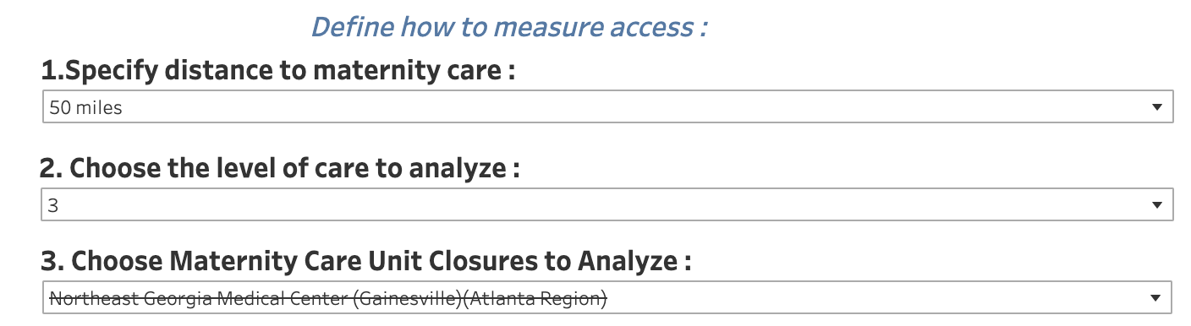

The map in the dashboard visually represents the accessibility of maternity care across Georgia, distinguishing between areas that are within the defined access range, those that remain without access, and those that lose access due to closures. The geospatial map is built using geographic shapefiles and is layered to show county borders, hospital locations, and block group boundaries. Each block group is color-coded to indicate its access status, providing a clear visual distinction between "non-desert" areas (with adequate access) and "desert" areas (with inadequate access). This detailed representation helps users quickly identify regions that are most affected by OB unit closures. The map also has toolkit functionality which when hovered over a certain block group gives detailed information about the distance and name of the nearest hospital before and after closure.

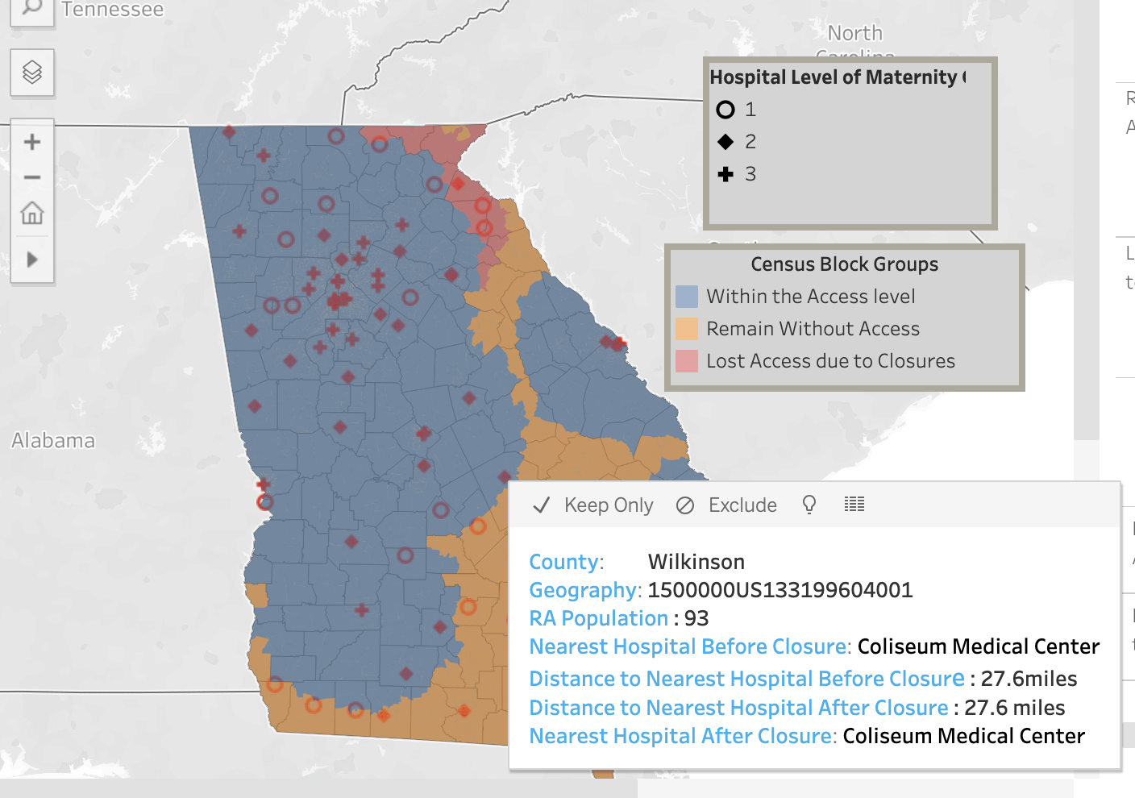

Additionally, the dashboard incorporates demographic data related to race and socio-economic factors. Bar plots accompanying the map display the percentage of reproductive-aged women within each racial and poverty group who either remain without access, have lost access due to closures, or are within the access level. This allows for an in-depth analysis of how different subgroups are impacted by changes in maternity care access. By dynamically updating these statistics based on user selections, the dashboard provides valuable insights into healthcare disparities and helps inform policy decisions aimed at improving maternal care accessibility in Georgia.

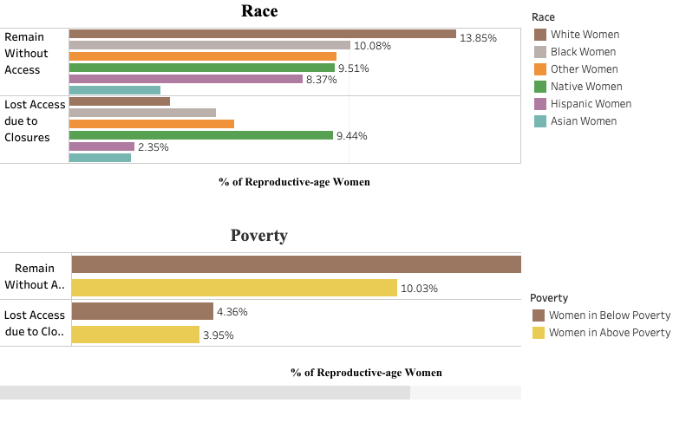

# 3. Results

Case Studies

1. Current state of access to care in Georgia
   1. Any level
   2. Level 3 only
2. Subpopulations most significantly affected by lack of access
   1. By race
   2. By socio-economic status
3. Impacts of hospital closures

# 4. Discussion

Major Contributions: dynamic view of access to care & easily used by public health practitioners

* Allows user specified access measures and comparison across measures
* Incorporates levels of care into access measures
* Allows user to explore hypothetical obstetric unit closures impact on specified access to care

Limitations

* Not considering out-of-state hospitals
* Aggregating data
* Travel distance – doesn't incorporate transportation

We present a dashboard that allows users to analyze maternity care access in the state of Georgia across multiple access measures. [Main findings]. This publicly available tool can help policymakers and hospital administrators visualize access to maternity care and determine areas to target improvements in risk-appropriate access to maternity care.

The current study and corresponding dashboard have limitations. First, we currently consider the state of Georgia independently, and we do not consider out-of-state hospitals or out-of-state demand for Georgia hospitals. Second, we aggregate data at the census block group level. Third, while we incorporate travel distance by road, we do not consider transportation modes or availability. Certain regions in Georgia may have lower rates of car ownership and public transportation availability, resulting in a larger travel burden. An additional barrier to access that we did not consider is insurance coverage. Finally, our analysis only considers potential access.

# 5. Conclusion

# References

# Tables and Figures

|  |  |
| --- | --- |
| **Datasets** |  |
| List of Hospitals | [Link](https://docs.google.com/spreadsheets/d/14V-KxMrRWrjH1PZcfO7rwGD3XVTFfpwiVJtErUyQFOU/edit#gid=1740256514) |
| Block Group Population Center | [Link](https://www.census.gov/) |
| Distance Matrix | [Code](https://colab.research.google.com/drive/1ox2zDK4AhOGgyCiyBT1enk0G8RwtkPrB#scrollTo=TcJZql36UGQL) |
| Count of Reproductive Aged Women on a Block group Level |  |
| Count of Reproductive Aged Women by race on a County, Census Tract and Block Group Level |  |
| Count of Reproductive Aged Women by poverty on a County, Census Tract and Block Group Level |  |

# Appendix/Extra Text

**Population Estimates**

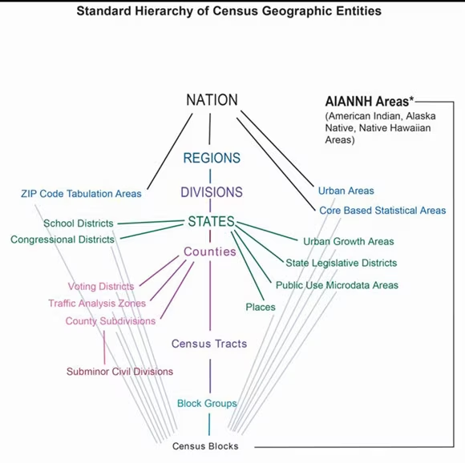

The diagram above shows the standard hierarchy of geographic entities in the United States, starting with the Block Group (BG) as the base level, followed by the Census Tract (CT), then counties, and finally states. Population datasets for Georgia are therefore collected at the Block Group, Census Tract, and County levels, with the reproductive age population defined as ages 18 to 44.

The United States Census Bureau website is a comprehensive resource that provides data, research, and insights into America's people, places, and economy. It offers a wealth of demographic, economic, and geographic data, along with survey information, research publications, and updates on emerging trends and events. As a central hub for researchers, policymakers, and the public, the platform enables users to access the latest census data and explore various bureau programs. This website is crucial for obtaining population counts across different geographic levels and demographic characteristics, such as poverty and health insurance status.

We source data from data.census.gov ([link](https://data.census.gov/table/ACSDT5Y2022.B27001?t=Age%20and%20Sex:Health%20Insurance&g=040XX00US18$1400000)) to ascertain the count of reproductive-aged women in the state of Georgia across various block groups. Additionally, we analyze this demographic by various characteristics such as race, poverty level, and health insurance access across three geographic levels: County, Census Tracts, and Block Groups.

For County and Census Tracts, the data regarding the count of reproductive-aged women by different features is directly extracted from the data.census.gov website. However, this specific breakdown is not directly available for Block Groups. To address this, we employ a methodological approach to estimate these counts at the Block Group level.

Firstly, we utilize data that provides the count of reproductive-aged women for each feature at the Census Tract level to determine the proportion of women in each tract. This proportional data is then merged with a Block Group dataset, where each row includes the total number of reproductive-aged women in the block group and their distribution as a fraction of the Census Tract they belong to. We then calculate the count of reproductive-aged women for these features at the Block Group level by multiplying the total number in each block group by the derived proportion from their corresponding Census Tract.

**Methods – Dashboard Creation**

### 2.2.1 Data Preprocessing

The initial phase of the analysis involved integrating a diverse array of data sources, including geographic shapefiles at both county and block group levels, as well as population center data specific to block groups. This was complemented by hospital location data, which encompassed three distinct levels, such as Level1, Level2 and Level3. To facilitate a comprehensive analysis, these datasets were merged, aligning population centers with their respective healthcare access points.

Critical to the subsequent analysis was the calculation of distances between each block group and the available hospitals. These distances, derived from geographic coordinates, serve as the foundation for several key features in the dataset. "MinDist_Hospital" pinpoints the nearest hospital for each block group, providing essential information on healthcare proximity. "MinDist_Distance" quantifies this proximity, offering a numerical measure of accessibility. These engineered features enhance the dataset's analytical potential, enabling a more nuanced exploration of the relationship between population distribution and healthcare access.

The resulting preprocessed dataframe is characterized by its extensive size and intricate structure. With 5,533 block groups and 81 hospitals distributed across three hierarchical levels, the total number of unique block group-hospital combinations is substantial. This translates to a dataframe comprising 896346(5,533 * 27 * 3 + 5,533 * 81) observations, each representing a specific block group's relationship with a particular hospital. This comprehensive dataset serves as a rich resource for investigating healthcare access patterns and disparities when consumed into a tableau dashboard.

Additionally, demographic data pertaining to race and poverty were incorporated at the block group level. Specific features of interest were derived from this data, including the count of reproductive-aged women within each racial group for every block group. Further analysis of poverty data involved generating features that quantified the number of reproductive-aged women both above and below the poverty line for each block group.

### **2.2.2 Creating the map**

In Tableau, crafting a geospatial map involves leveraging geographic shapefiles to delineate boundaries corresponding to the selected geographic level. The dashboard architecture typically comprises three intertwined layers. At the foundation lies the county borders, providing a contextual backdrop. Overlapping this, the middle layer showcases hospital locations, plotted as markers for easy identification. Finally, the topmost layer focuses on the operational aspect, operating at the block group level.

Within this top layer, the initial step entails generating the geospatial borders of block groups through shapefiles. But what really makes this layer special is how we figure out who has easy access to hospitals and who doesn't. In my approach, I utilized population centers within block groups to gauge the distance between each block group and the nearest hospital. Based on this, we split neighborhoods into two groups: those with good access ("non-desert") and those with limited access ("desert"). Then, the above discrimination decides the color associated with each block group. In addition to this, racial and poverty characteristics are also embedded into the dashboard using bar plots in connection with the geo-map, which primarily represents the respective percentage of women within certain race or poverty level mapped to each category of access.

### 2.2.3 Computation of statistics – who lacks access, subgroups

The three main selections within the dashboard i.e access threshold in miles, level of care and hospital closure selector decides the access definition. Basis the above selection, the hospital closest to each block group is decided dynamically and then compared against the access threshold to discriminate it as desert or non-desert. Similar approach is followed before hospital closure. Now, the category assigned to each block group post closure is compared against pre-closure to decide if its “Within the Access”, “Remains Without Access” or “Lost Access Due to Closure”.

For poverty and race, the respective percentage of reproductive aged women, be it within race or poverty level is calculated dynamically based on hospital closure selector to represent the distribution across the access dimension.